Langtidsudvikling og næringsdynamik ved reduceret eutrofiering i en stor lavvandet sø, Arresø
Fig.1 Kort over tidligere kontakt med Kattegat. Jonas Se Søer – en beskyttet naturtype forbindelser (A), Vegetationsudviklingen.

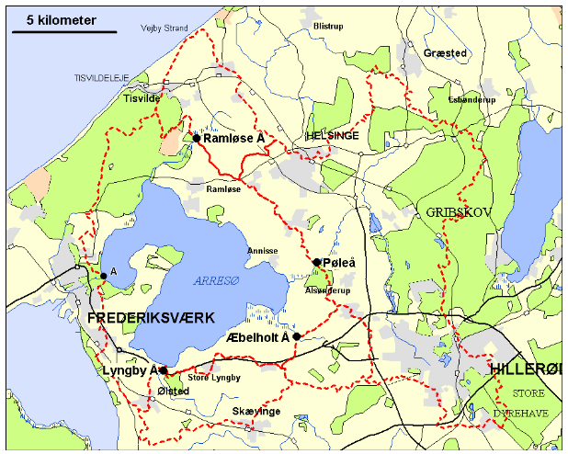
Fig. 1. Map of Lake Arresø, outline of the catchment (stippled red) and the two main cities (Hillerød and Helsinge in grey). The four main stream-inlets (Ramløse Å, Pøleå, Æbelholt Å and Lyngby Å, blue lines) and forests (green) are also shown.

Fig. 3. Vegetationsudviklingen. Jonas Se Søer – en beskyttet naturtype.
Figur S1. Chlorophyll concentration and Secchi-depth in Lake Arresø over time. Mean summer values (the lines) and ranges (coloured). Jonas: Benyt to paneler. Summer Secchi depth (cm).
Tabel S 1. Vandplanter i søen over tid. Beregn arealdækningen (inferiør netop nu). JONAS
Fig. 4. Mean summer and winter concentrations of inorganic dissolved phosphate, nitrate and ammonia in the outlet from Lake Arresø over ten years (1967-1976) based on monthly measurements.
Fig 8. Summer concentrations of TP, TN and TN: TP ratio during summer in Lake Arresø over 50 years. Mean values (the line) and ranges are shown.

Massebalance
Fig. 5. Annual input and output of TP and TN in Lake Arresø over 50 years.

Fig 6. Annual retention of TP and TN versus water retention time (WRT) in Lake Arresø over many years. Nutrient retention (i.e. removal) is shown with positive value.

Figur S 2. Annual input (x) vs. annual outflow of TN (y) in the same year from Lake Arresø. The stippled line shows input = outflow (1:1 line). Inflow exceeds outflow in all years. The punctured line showing the relationship between measurements (y vs x, omitting the outlier in parenthesis) gradually approaches the 1:1 line at decreasing TN input suggesting linearly decreasing losses by denitrification as TN inout declines. Sæt klamme om outliner (der er tæt på 1:1) og beregn GM-regression og angiv ligningen.
Fig. 7. Annual input (above zero line) and output (below zero line) of TP and TN in Lake Strødam and Lake Solbjerg and Lake Strødam in the years following their construction along the Stream Pøleå. .

Sedimenter
Sedimentkarakteristik
Figur 9. Sediment TP concentrations (per DW) with depth in different years.
Figur 10. The decrease of concentrations of TP (per DW), organic carbon (per DW) and TP (per organic carbon) in surface sediment (0-5 cm depth) over the study period.
Afsæt ounkterne som åbne cirkler, så vi kan se dem alle!
Tabel 1.
Basic characteristics of Lake Arresø. For water retention time and alkalinity values are presented as mean (median, min-max).
Catchment area (km²) | 215
Cultivated area (km²) | 116
Lake area (km²) | 39.9
Mean depth (m) | 3.1
Max depth (m) | 5.9
Water retention time (years) | 2.4 (3.1, 1.3–5.9)
Alkalinity (mmol l⁻¹)* | 2.47 (2.47, 1.75–3.35)

* Alkalinity is calculated from summer values from 2000 to 2024

Tabel 2. Mean annual input of TP and TN to Lake Arresø and outlets from sewage treatment plants in 1985-1987 and 2018-2021. Mean annual input to Lake Arresø in the 1970s was 82 tons TP and 508 tons TN. Outlets during storm flow events in the two main cities are included in the sewage outlets in 2028-2021.
 | 1970s |  | 1985–1987 |  | 2018–2021
Sources and proportions | ton year⁻¹
 | TP | TN | TP | TN | TP | TN
Input to Lake Arresø | 81 | 508 | 72 | 449 | 6.84 | 247
% in 2018-21 of 85-87 |  |  |  |  | 9.5 | 55
Output from water treatment plants and by stormflow |  |  | 62.6 | 199 | 2.22 | 23.3
% input from urban areas of lake inlets |  |  | 87 | 44 | 32 | 9
% input from urban areas in 1985-87 of |  |  |  |  | 3.5 | 11.7

Tabel 3. TP-pools in sediment depth strata over the period. Tons P
Sediment depth |  | 1988 | 1997 | 2002 | 2009 | 2014 | 2018
0–2 |  | 42.98 | 44.91 | 47.96 | 30.89 | 33.13 | 35.47
0–5 |  | 140.3 | 179.7 | 175.8 | 111.1 | 107.5 | 125.3
0–10 |  | 338 | 459 | 350 | 276 | 275 | 335
0–20 |  | 730 | 1111 | 749 | 607 | 599 | 781
0–40 |  | 1616 | 2719 | 1499 | 1206 | 1289 | 1716

Tabel S2. Mean chemical composition with depth in sediment (organisk stof, calcium, Fe and Fe:TP ratio).
Sediment depth | Organic carbon |  | Calcium |  | Fe |  | Fe:TP ratio
Sediment depth | mg (g DW)⁻¹
Sediment depth | Mean | Range | Mean | Range | Mean | Range | Mean | Range
0–2 | 372 | 277–450 | 165 | 152–177 | 9.7 | 6.8–13.7 | 7.2 | 4.0–10.87
2–5 | 346 | 237–420 | 147 | 136–157 | 10.3 | 7.1–13.3 | 9.3 | 3.7–17.1
5–10 | 300 | 18–360 | 132 | 113–150 | 11.1 | 6.9–14.4 | 11.6 | 3.9–21.8
10–20 | 270 | 180–340 | 156 | 132–180 | 12.1 | 9.8–15.8 | 13.6 | 9.6–24.7
20–30 | 231 | 184–314 | 134 | 111–156 | 13.5 | 9.5–15.7 | 16.3 | 10.3–22.8
30–40 | 220 | 188–263 | 126 | 125–127 | 14.1 | 11.6–17.7 | 20.8 | 15.0–25.6

Tabel S3. C/N, N/P and C/P over årene og mod dybden
Sediment depth | 1988 | 1993 | 1997 | 1988 | 1997 | 1988 | 1993 | 1997 | 2002 | 2009 | 2014 | 2018
Sediment depth | C/N |  |  | N/P |  | C/P
0–2 | 10.0 (0.65) | 8.1 (0.7) | 7.6 (0.4) | 7.83 (0.62) | 12.1 (0.22) | 78.3 (1.59) | 83 (24) | 98.0 (6.5) | 96.7 | 108.7 | 100.7 | 91.2
2–5 | 9.64 (0.41) | 7.4 (0.03) | 7.3 (0.3) | 8.14 (0.48) | 12.3 (0.79) | 78.4 (1.52) | 98 (21) | 94.5 (5.7) | 111.7 | 101.1 | 95.8 | 100.9
5–10 | 9.43 (1.05) | 7.5 (0.06) | 7.2 (0.3) | 9.18 (0.95) | 12.9 (1.8) | 86.2 (4.8) | 141 (8) | 94.3 (29.8) | 111.7 | 104.5 | 79.1 | 77.8
10–20 | 8.06 (0.23) | 7.4 (0.2) | 7.7 (0.2) | 10.5 (1.2) | 11.3 (0.77) | 93 (6) | 142 (6) | 90.6 (4.6) | 123.2 | 118.2 | 107.5 | 82.3
20–30 | 6.81 (0.51) | 7.7 (0.2) | 6.3 (0.5) | 12.1 (1.4) | 11.4 (1.1) | 107 (8) | 123 (5) | 76.3 (14.1) | 143.1 | 125.2 | 125.4 | 137.9
30–40 | 8.18 (0.06) | 7.9 (0.3) | 8.0 (0.2) | 16.0 (1.9) | 13.1 (3.6) | 138 (19) | 141 (38) | 105.5 (18.8) | 153.2 | 240.7 | 156.1 | 110.8

Tabel S4. P-associeret med forskellige stoffer
Sediment depth | % P-Fe+Ad | % P-organic | % P-Ca | % P-Al | % P-residual
0–2 | 24.39 | 26.81 | 35.40 | 3.00 | 10.41
2–5 | 13.18 | 30.26 | 38.80 | 3.10 | 14.65
5–10 | 15.39 | 30.44 | 37.90 | 1.00 | 15.27
10–20 | 12.85 | 35.18 | 30.90 | 2.80 | 18.27
20–30 | 13.35 | 28.52 | 35.80 | 5.40 | 16.93
30–40 | 12.51 | 37.14 | 30.50 | 1.30 | 18.55

